Waked Lunch – Steel Mills & Dirty Windshields

2022

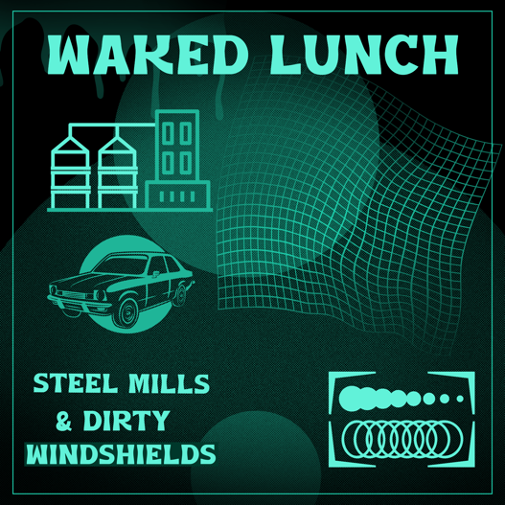

Title | Album | Run Time | Key | BPM | Tags | Additional Comments
Blue Collar Bottom Dollar | Steel Mills & Dirty Windshields | 5:05 | Amaj | 75
Burlap | Steel Mills & Dirty Windshields | 5:25 | F#maj | 82
Coldwater Creek (Alternate Ending) | Steel Mills & Dirty Windshields | 5:00 | Dmaj | 66
Flyaway Little Blue Jay | Steel Mills & Dirty Windshields | 4:57 | Amaj | 120
Lightning Bugs & Lemonade | Steel Mills & Dirty Windshields | 5:14 | Amaj | 78
Shootin’ in the Dark | Steel Mills & Dirty Windshields | 5:26 | Fmaj | 78
Silver Suns | Steel Mills & Dirty Windshields | 5:02 | Emaj | 80
Sundown in a No Sleep Town | Steel Mills & Dirty Windshields | 4:25 | Dmaj | 132

Track Order:
- Blue Collar Bottom Dollar
- Flyaway Little Blue Jay
- Lightning Bugs & Lemonade
- Sundown in a No Sleep Town
- Silver Suns
- Shootin’ in the Dark
- Burlap
- Coldwater Creek (Alternate Ending)

Run Time: 41 mins

Album Description: Steel Mills & Dirty Windshields is the third of four pandemic albums being released by Waked Lunch in 2022. Lockdown proved to be inspiring and so Waked Lunch got to work. Steel Mills & Dirty Windshields is comprised of 8 “country” tracks. After completing Silos & Halos, Waked Lunch still had a bit of the country bug, so Steel Mills & Dirty Windshields was born.

Album Credits: All songs by Rosemary Haskins. Arranged, Produced, Engineered, Mixed, and Mastered by Rosemary Haskins at WaterWorks Entertainment Studios in Nashville, TN. Copyright 2022 Rosemary Haskins/WWE Publishing.
For more info, visit:
www.wakedlunch.com
OR
www.rosemaryrocks.com
www.waterworksentertainment.com
For licensing inquiries, contact Rosemary at wakedlunch@gmail.com

